10 REAL-TIME WIRESHARK
LAB EXPERIMENTS
ITA03 | MOBILE COMPUTING | UNIT I ONLY
Student scenario questions + step-by-step Windows procedures + expected results
PAVITHRA K (192424220)
Mobile Computing – ITA0325
COURSE UNIT | SCOPE
Unit I | Introduction to Mobile Cellular Systems
Software | Wireshark (Windows 10/11, with Npcap)
Programming required | None; Command Prompt / PowerShell test commands only
Network setup | Smartphone mobile-data hotspot; authorized campus Wi-Fi for experiments 8 and 10
Lab method | Live capture -> filter -> inspect -> evidence -> interpretation

This manual is based on the topics listed under Unit I of the uploaded ITA03 Mobile Computing syllabus: fundamentals, cellular-network concepts, access channels, mobile network architecture, protocol stacks, core networks, PLMN, mobility, handoff, roaming, performance criteria and cellular operations.

Essential accuracy note
An ordinary Wireshark capture on a Windows laptop attached to a smartphone hotspot sees the laptop-side IP traffic, not LTE/5G radio signaling. A phone hotspot is a useful real-time teaching setup, but it does NOT expose cellular frequency reuse, interference measurements, RACH procedures, GSM BSS/NSS signaling, PLMN registration, or native cellular handover. The experiments clearly label these as analogies or architectural interpretation.
Use only your own device traffic or traffic you are authorized to capture. Do not disclose saved PCAP files containing sensitive addresses, tokens, or application metadata.

Experiment map
No. | Real-time scenario / experiment | Unit I concept
1 | Trace a Smartphone Hotspot Communication Path | Fundamentals of mobile computing
2 | Observe Address Allocation When Joining a Mobile Hotspot | Cellular system operations
3 | Find the First-Hop Gateway Using ARP | Network architecture
4 | Investigate Why a Mobile Website Opens by Name | Mobile computing services
5 | Verify Reliable Access Through a TCP Three-Way Handshake | Mobile network protocol stacks
6 | Classify Shared-Network Traffic: Broadcast vs Unicast | Access channels (conceptual comparison)
7 | Trace the Route from a Mobile Hotspot Toward the Internet | Mobile network architecture
8 | Observe Service Interruption During a Network Switch | Mobility
9 | Assess Mobile Hotspot Performance at Two Indoor Locations | Performance criteria
10 | Compare Campus Wi-Fi and Cellular-Data Hotspot Paths | Core networks

One-time setup before Experiment 1
01. Install Wireshark from https://www.wireshark.org/download.html; install the offered Npcap capture component.
02. Turn on the phone hotspot and connect the Windows laptop. For each test use only the Wi-Fi interface carrying that connection.
03. Open Wireshark: choose the active Wi-Fi adapter by looking at the live packet activity graph; double-click to start capture.
04. Generate traffic only after capture starts. Click the red Stop square before filtering or saving.
05. Use the Display Filter bar (near the top of Wireshark), not the Capture Filter field, for filters in this manual. Press Enter to apply.
06. Click a packet and expand Internet Protocol Version 4, Transmission Control Protocol, User Datagram Protocol, DNS, DHCP/BOOTP, ICMP or ARP as applicable.
07. Save each capture as .pcapng and record only observed values. The host IP, MAC, TTL, delays, packet counts and hop count will vary.
08. When a network disconnect interrupts capture, collect two short captures rather than trying to maintain a broken recording.

How students should write the record
For each experiment: (1) write the scenario and task; (2) record aim; (3) list the filter(s); (4) perform steps; (5) enter actual observation values; (6) attach a screenshot; (7) write a result based on the capture. A negative or empty result is acceptable if diagnosed and documented.

Common troubleshooting
- No packets: verify the correct interface and that Wireshark/Npcap is permitted to capture; disconnect from any unintended VPN if allowed by your institution.
- No DHCP or ARP: the laptop may be using a cached lease/address mapping. Reconnect, renew, or clear cache only as directed and authorized.
- No DNS from browser: encrypted DNS may be used. Generate an explicit nslookup as required.
- HTTPS site loads using UDP rather than TCP: the browser may use QUIC/HTTP3. Experiment 5 deliberately uses a TCP connection test.
- No traceroute middle-hop reply: a router may be configured not to answer ICMP; it does not necessarily indicate packet loss for normal applications.
- No 802.11 beacons or LTE messages: ordinary Wi-Fi capture often presents Ethernet-like frames; raw Wi-Fi management frames require compatible monitor-mode hardware, and LTE signaling requires separate tools.

EXPERIMENT 01

Trace a Smartphone Hotspot Communication Path
Syllabus alignment: Fundamentals of mobile computing; mobile station; mobile network architecture; protocol stacks
Real-life scenario
A student opens a learning website on a Windows laptop connected to a smartphone hotspot. The faculty asks: Which packets can be observed on the laptop, and where does the mobile operator network begin?
Lab question / problem statement
Using live Wireshark traffic, identify the laptop-to-hotspot IP communication and at least three upper-layer protocols. Draw the end-to-end path and label the boundaries Wireshark cannot observe.
Aim
To capture and analyze live network traffic in Wireshark in order to trace a smartphone hotspot communication path.
Requirements
Windows laptop with Wireshark/Npcap; smartphone with mobile data and hotspot; permission to use the data plan.
Wireshark display filters
dns || tcp || udp || icmp
ip.addr == <LAPTOP_IP> (replace the placeholder with your actual IPv4 address)

Step-by-step procedure
01. Enable mobile data and Personal Hotspot on your smartphone; note the hotspot name (SSID).
02. Connect the Windows laptop to the hotspot using Settings > Network & Internet > Wi-Fi.
03. Open Command Prompt and run ipconfig. Note the laptop IPv4 address and Default Gateway under the Wi-Fi adapter.
04. Open Wireshark. In the welcome screen, locate the Wi-Fi interface showing activity and double-click it to start a capture.
05. In a browser, open https://example.com and then https://www.wikipedia.org; let each page finish loading.
06. In Command Prompt, run ping -n 4 1.1.1.1 to generate clearly identifiable ICMP traffic.
07. Stop capture using the red square icon. Apply the first display filter, then expand one IPv4 packet and one TCP or UDP packet in Packet Details.
08. Identify source and destination IP addresses, protocol names, and whether each packet is outbound or inbound.
09. Save the capture via File > Save As as E01_Hotspot_Path.pcapng and take a screenshot of the filtered packet list.
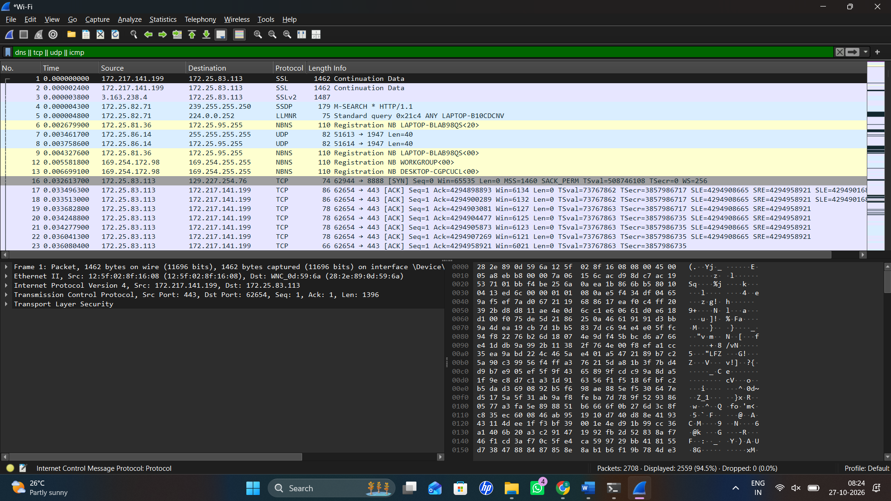

Student observation sheet (fill with actual values)
Observation to record | Value from YOUR capture
Laptop IPv4 address | ______172.25.83.113______________________
Default gateway (hotspot-side address) | ________172.25.80.1____________________
Three observed protocols | __________TCP, UDP, SSL__________________
One external destination IP | _________172.217.141.199___________________
Which parts are not visible in this capture? | ________Cellular radio signaling, base-station communication procedures, and mobile operator core-network signaling.____________________
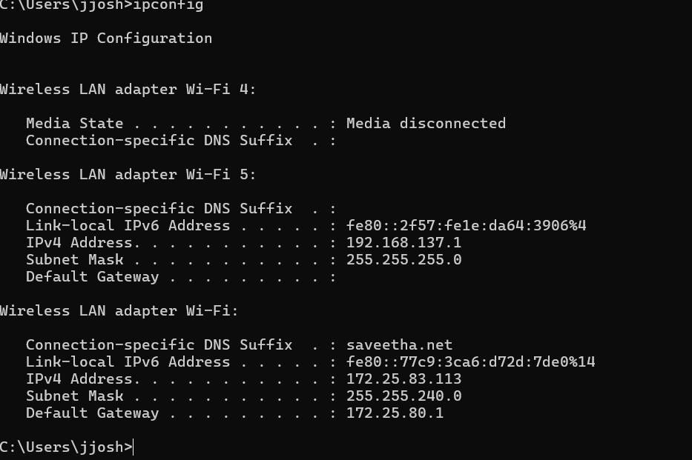

Expected output / how to interpret it
- Laptop-source traffic and reply traffic should be visible; exact protocols vary with browser and network.
- The laptop can see the IP gateway/hotspot-facing segment and Internet packets, not the operator’s private radio control procedures.
- The physical cellular Base Station Subsystem (BSS), Network Switching Subsystem (NSS), SIM registration and PLMN ID are not decoded from a normal laptop hotspot capture.
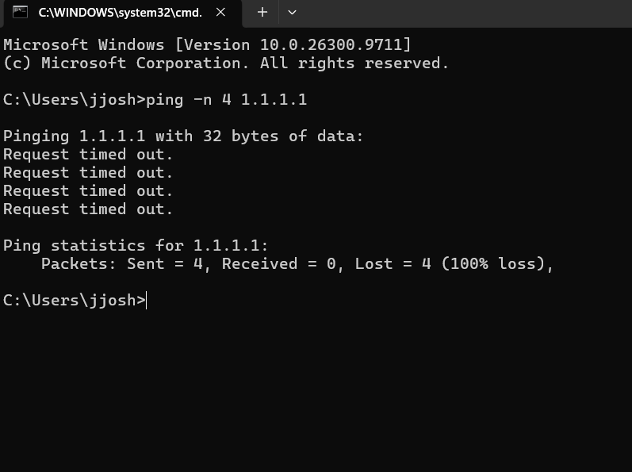

If expected packets are absent
If the browser uses encrypted DNS/QUIC, keep the observable TCP/UDP/IP packets; do not assume DNS or TLS will always appear.
Result to write after completion
The student identified end-user protocol traffic over a mobile-data hotspot and distinguished directly observable IP packets from the cellular radio/core components inferred from the architecture.
Two analysis / viva questions
1. Why does the gateway IP not identify the actual cellular base station?
2. Which protocol fields tell you whether a packet travelled from the laptop toward the Internet?
What to submit: E01 capture file(s) + screenshot of relevant packets + completed observation table + a two- or three-sentence conclusion.

EXPERIMENT 02

Observe Address Allocation When Joining a Mobile Hotspot
Syllabus alignment: Cellular system operations; network access; address configuration
Real-life scenario
A newly connected student laptop displays “Connected” to the mobile hotspot but cannot browse until it receives its network configuration.
Lab question / problem statement
Capture the address-allocation traffic when the laptop joins the hotspot. Determine whether Discover, Offer, Request and Acknowledgement (DORA) messages were observed.
Aim
To capture and analyze live network traffic in Wireshark in order to observe address allocation when joining a mobile hotspot.
Requirements
Windows laptop, smartphone hotspot, Wireshark; the hotspot must be using DHCP (normal for most phones).
Wireshark display filters
bootp
udp.port == 67 || udp.port == 68

Step-by-step procedure
01. Connect to the smartphone hotspot and verify Internet access. Open Command Prompt and run ipconfig /all; record DHCP Enabled, IPv4 address and Lease Obtained if displayed.
02. Launch Wireshark and begin capturing on the Wi-Fi adapter BEFORE forcing a lease renewal.
03. Open Command Prompt. If the adapter is named Wi-Fi, run ipconfig /release "Wi-Fi" and then ipconfig /renew "Wi-Fi". If its name differs, replace Wi-Fi with that adapter name.
04. If release/renew does not produce a new exchange, disconnect from the hotspot and reconnect while the capture remains active.
05. Stop Wireshark capture and enter the display filter bootp.
06. Click available DHCP messages. Expand Bootstrap Protocol / Dynamic Host Configuration Protocol to examine Message Type, Transaction ID, offered IP, server ID and lease data.
07. Count which of Discover, Offer, Request and ACK appear; do not invent missing messages.
08. Compare the assigned IPv4 address with the output from ipconfig /all.
09. Save E02_DHCP_Hotspot.pcapng and a screenshot of the DHCP packets.
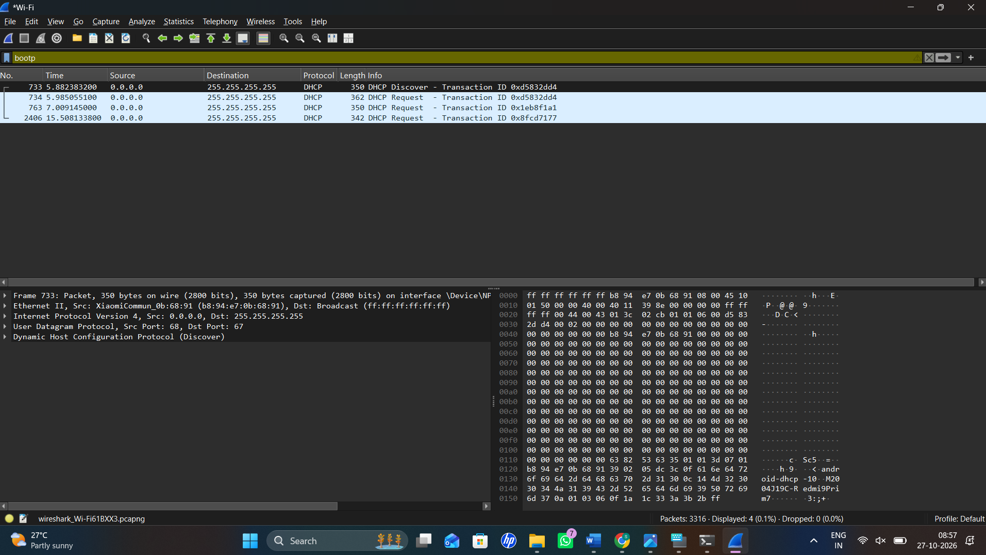

Student observation sheet (fill with actual values)
Observation to record | Value from YOUR capture
DHCP Discover seen? (Yes/No) | ________ Yes____________________
DHCP Offer seen? (Yes/No) | _________ Not visible  _________ Yes__________
DHCP Request seen? (Yes/No) | ________ Not visible____________________
DHCP ACK seen? (Yes/No) | __________ 172.25.83.113__________________
Assigned IPv4 and gateway | __________ 172.25.80.1__________________

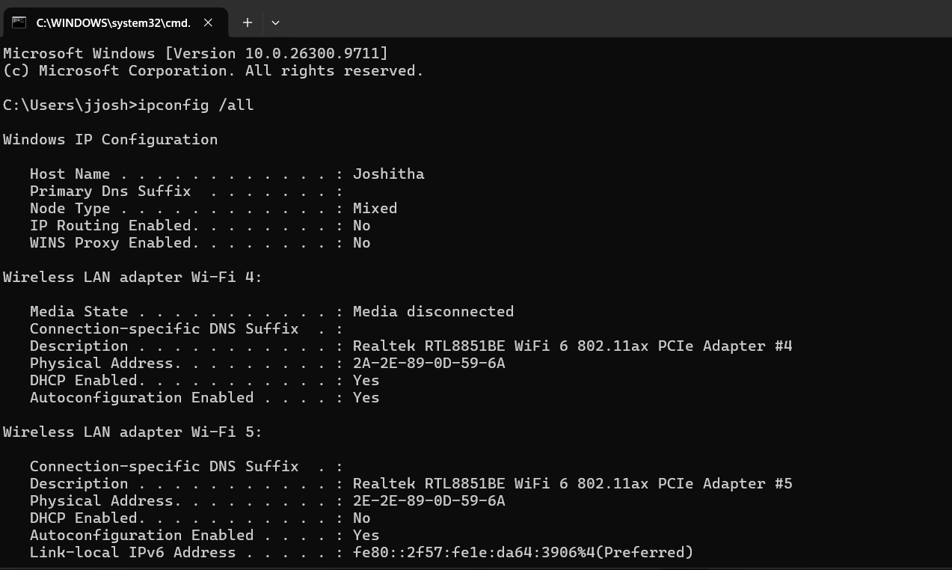

Expected output / how to interpret it
- A DHCP exchange or renewal-related packets are often visible when joining/renewing the hotspot network.
- A renewal may show Request and ACK only; a complete DORA sequence is not guaranteed.
- The assigned private address normally belongs to the hotspot’s local subnet.
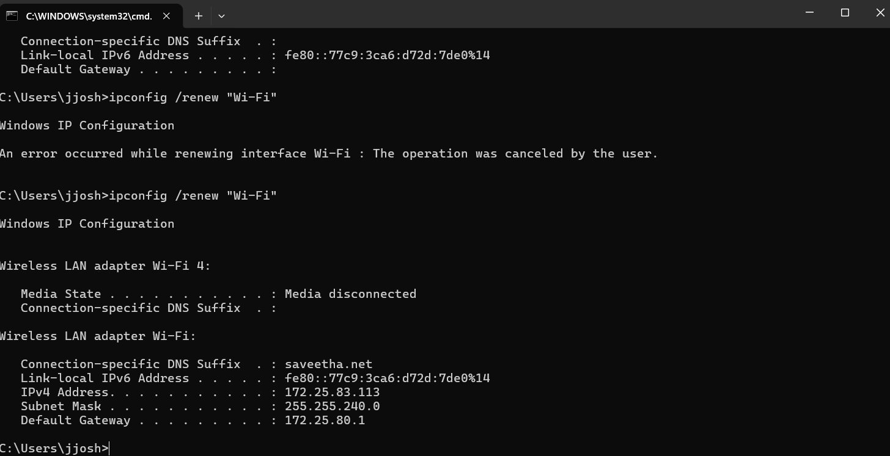
If expected packets are absent
If the Wi-Fi capture stops when the adapter disconnects, start a new capture just before reconnection and combine the observations; do not claim full DORA without all four packets.
Result to write after completion
The student verified how a client receives its IP configuration through the hotspot access network, using DHCP messages actually captured.
Two analysis / viva questions
1. What is the purpose of the DHCP lease?
2. Why might a capture contain only DHCP Request and ACK?
What to submit: E02 capture file(s) + screenshot of relevant packets + completed observation table + a two- or three-sentence conclusion.

EXPERIMENT 03

Find the First-Hop Gateway Using ARP
Syllabus alignment: Network architecture; access-network operation; mobile station to first hop
Real-life scenario
A student knows the IP address of the Internet site but cannot explain how a packet is delivered across the local link to the hotspot.
Lab question / problem statement
Prove how the laptop resolves the gateway’s IPv4 address into a link-layer destination address before transmitting IP packets.
Aim
To capture and analyze live network traffic in Wireshark in order to find the first-hop gateway using arp.
Requirements
Windows laptop and an IPv4 hotspot or Wi-Fi network; Wireshark.
Wireshark display filters
arp
arp || icmp

Step-by-step procedure
01. Connect to the hotspot and run ipconfig. Write down the Default Gateway IPv4 address.
02. Run arp -a and check whether an entry for the gateway is already cached.
03. Start Wireshark capture on the active Wi-Fi interface.
04. To stimulate fresh ARP, use an approved administrator Command Prompt and run arp -d *; alternatively disconnect and reconnect to the hotspot to refresh the neighbour entry.
05. Run ping -n 3 <GATEWAY_IP>, replacing the placeholder with the address recorded from ipconfig.
06. Stop capture and apply arp. Locate a “Who has …? Tell …” request and an “is at …” reply if generated.
07. Expand Address Resolution Protocol and record Sender Protocol Address, Target Protocol Address and Sender Hardware Address.
08. Apply arp || icmp to show the relationship between address resolution and subsequent communication.
09. Save E03_ARP_Gateway.pcapng and a screenshot of a request and matching reply, if visible.
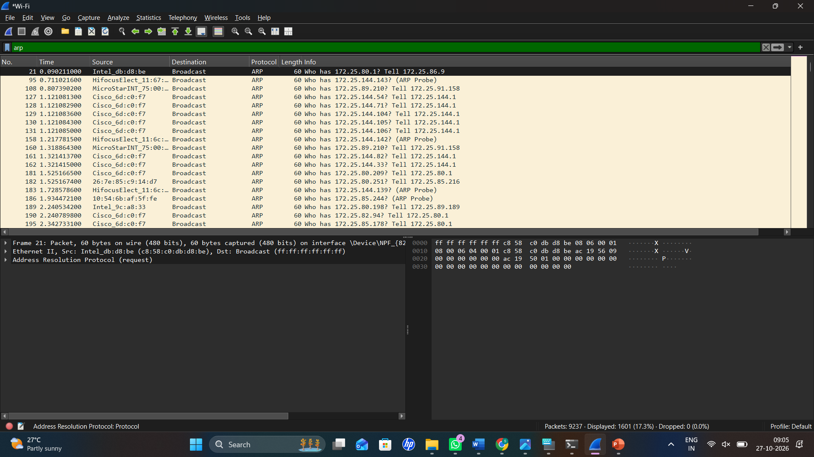

Student observation sheet (fill with actual values)
Observation to record | Value from YOUR capture
Gateway IPv4 address | __________ 172.25.80.1__________________
Gateway MAC (if learned) | ____________ 24-D5-E4-6D-C0-F7________________
ARP request source | _________ 172.25.83.113___________________
ARP target IP | __________ 172.25.80.1__________________
Was an ARP reply observed? | ________ Check Wireshark for a matching ARP reply; the arp -a entry confirms the gateway MAC is cached, but does not alone prove the reply was captured.____________________

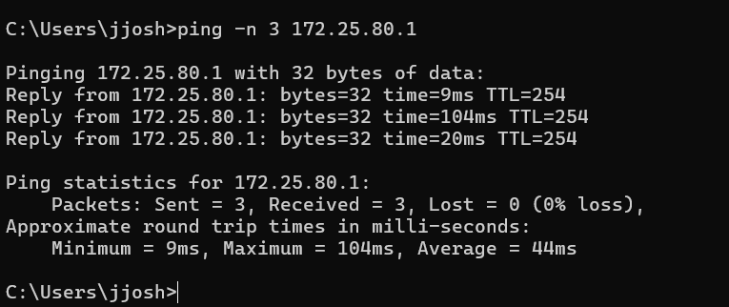

Expected output / how to interpret it
- The laptop typically sends an ARP request for the local gateway if no valid neighbour entry is cached.
- An ARP reply may disclose the local gateway’s link-layer address; exact address values differ by device.
- ARP is only a local IPv4 link operation and does not reveal the remote cellular base station or 4G/5G control plane.
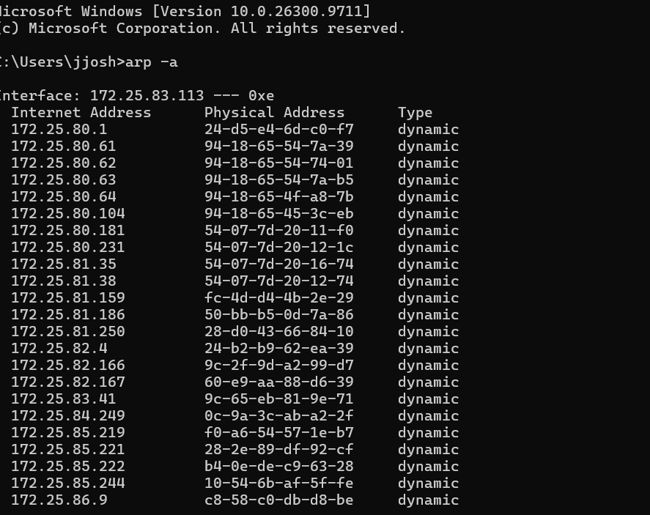
If expected packets are absent
If ARP is absent because the entry was cached, reconnect to the hotspot or repeat after a permitted ARP-cache clear. IPv6 uses Neighbor Discovery, not ARP.
Result to write after completion
The student demonstrated first-hop address resolution on the access network and distinguished local delivery from Internet routing.
Two analysis / viva questions
1. Why is ARP needed for local IPv4 delivery?
2. Would an IPv6-only interface use ARP?
What to submit: E03 capture file(s) + screenshot of relevant packets + completed observation table + a two- or three-sentence conclusion.

EXPERIMENT 04

Investigate Why a Mobile Website Opens by Name
Syllabus alignment: Mobile computing services; network protocol stacks; cellular operations
Real-life scenario
A campus learner can reach a server by IP address but reports that some websites fail to load by name on mobile data.
Lab question / problem statement
Use Wireshark to identify DNS queries and responses generated by explicit lookups, then explain their role before mobile Internet communication.
Aim
To capture and analyze live network traffic in Wireshark in order to investigate why a mobile website opens by name.
Requirements
Windows laptop, hotspot or permitted campus Wi-Fi, Wireshark.
Wireshark display filters
dns
dns.qry.name contains "example"

Step-by-step procedure
01. Connect to the mobile hotspot and open Wireshark on the active Wi-Fi interface.
02. Start a new capture and leave it running.
03. Open Command Prompt and run nslookup example.com followed by nslookup www.wikipedia.org.
04. Stop capture. Enter the display filter dns and identify queries with Transaction ID and Query Name.
05. Select the matching response packet and expand Domain Name System to inspect Answers and any returned A or AAAA records.
06. Record the resolver’s IP address from the packet source/destination and compare returned addresses with Command Prompt output.
07. Note whether an answer is missing, blocked or different from a previous lookup; do not assume one fixed IP per domain.
08. Save E04_DNS_MobileInternet.pcapng with one query/response screenshot.
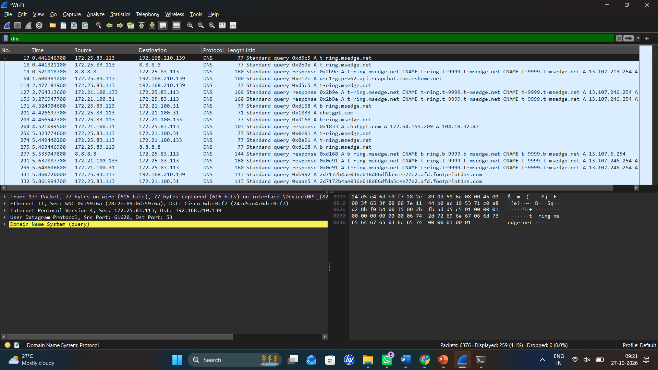

Student observation sheet (fill with actual values)
Observation to record | Value from YOUR capture
Queried domain name | ___________ example.com_________________
Query type: A or AAAA | ____________A and AAAA (IPv4 and IPv6 addresses were returned; confirmed the query types in Wireshark)__ _________
DNS resolver IP | __________________8.8.8.8 (Google DNS)__________
Returned answer (if any) | _______________IPv4: 104.20.23.154, 172.66.147.243; IPv6: 2606:4700:10::6814:179a, 2606:4700:10::ac42:93f3  _____________
DNS response time / status | ____  Non-authoritative answer received; a 5-second timeout message was also observed  ________________________

Expected output / how to interpret it
- Traditional nslookup requests normally create plain DNS packets that Wireshark can decode.
- The response should show a name-to-address result or an explicit DNS status/error.
- A browser itself may use encrypted DNS, so browser activity alone is not a reliable DNS-capture trigger.
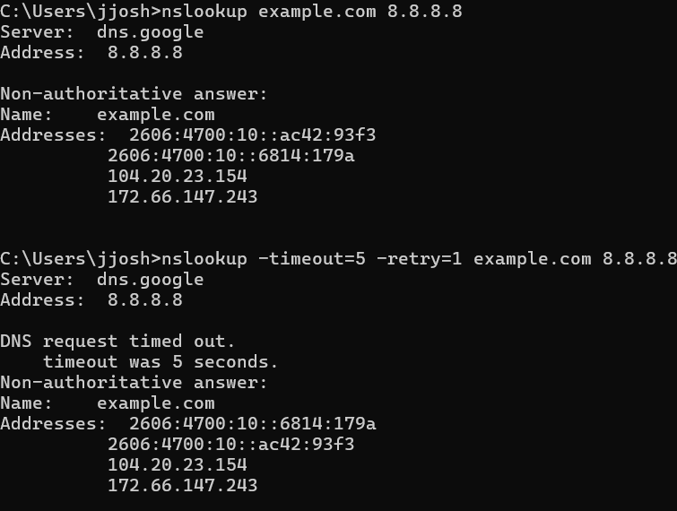
If expected packets are absent
If DNS packets are not visible, ensure you captured the right Wi-Fi adapter and run nslookup again while capturing. If using a VPN, capture the VPN or correct interface.
Result to write after completion
The student correlated live DNS request/response packets with domain-name resolution on a mobile-data access link.
Two analysis / viva questions
1. Why are A and AAAA responses different?
2. Why can successful ping to an IP coexist with failed name lookup?
What to submit: E04 capture file(s) + screenshot of relevant packets + completed observation table + a two- or three-sentence conclusion.

EXPERIMENT 05

Verify Reliable Access Through a TCP Three-Way Handshake
Syllabus alignment: Mobile network protocol stacks; performance criteria; cellular Internet service
Real-life scenario
A student claims that because a phone shows strong mobile signal, an educational website must open. The faculty asks them to verify whether a reliable transport connection can actually start.
Lab question / problem statement
Capture the TCP SYN, SYN-ACK and ACK exchange (or the actual connection failure) for an HTTPS service reached over the hotspot.
Aim
To capture and analyze live network traffic in Wireshark in order to verify reliable access through a tcp three-way handshake.
Requirements
Windows laptop and mobile hotspot; Wireshark; Windows PowerShell.
Wireshark display filters
tcp.port == 443
tcp.flags.syn == 1
tcp.analysis.retransmission

Step-by-step procedure
01. Connect the laptop to the mobile hotspot and start a new Wireshark capture.
02. Open Windows PowerShell (no administrator rights required for this test).
03. Run Test-NetConnection example.com -Port 443. This checks a TCP connection without requiring browser settings.
04. Stop capture and apply tcp.port == 443. Locate the destination resolved for example.com.
05. Inspect the first outgoing segment with SYN=1 and ACK=0, the server reply with SYN=1 and ACK=1, and the client ACK=1, if a connection succeeds.
06. Right-click a relevant TCP segment and choose Follow > TCP Stream to isolate that conversation, then close the stream window.
07. Record source/destination ports, initial TCP flags, round-trip timing approximated from packet timestamps, and the PowerShell TcpTestSucceeded result.
08. Optionally apply tcp.analysis.retransmission to check for reported retransmissions (zero is acceptable).
09. Save E05_TCP_Handshake.pcapng and a screenshot showing handshake flags.
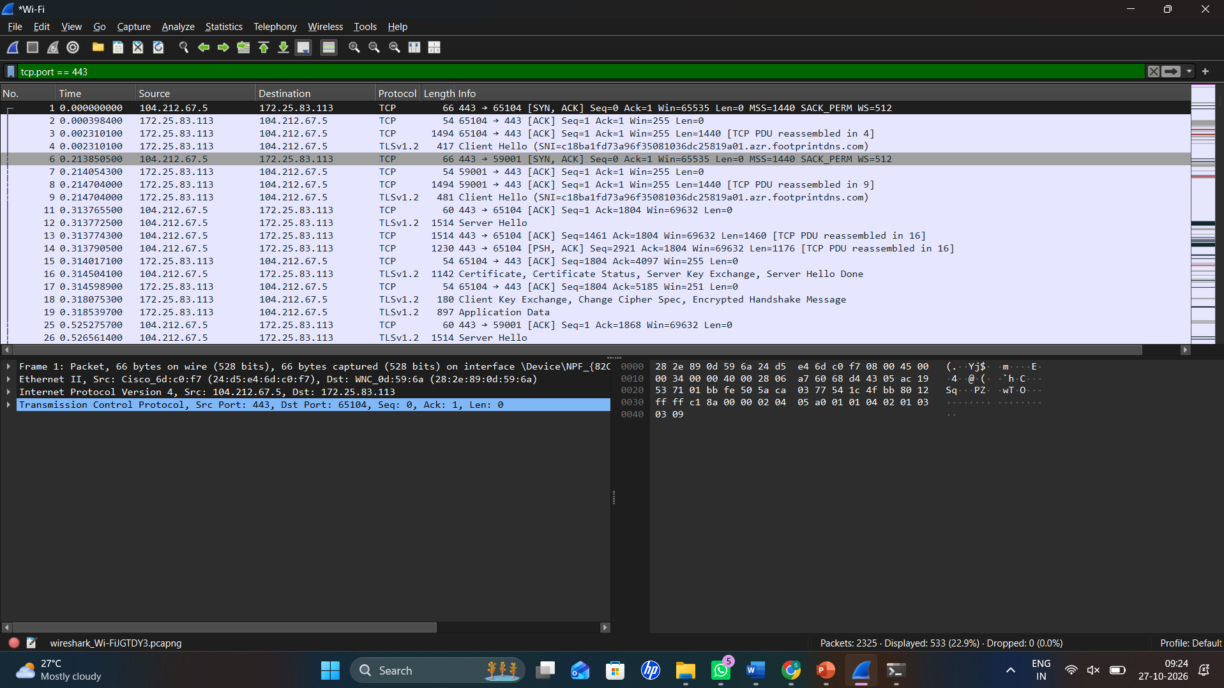

Student observation sheet (fill with actual values)
Observation to record | Value from YOUR capture
Client ephemeral source port | __________ 65104__________________
Server TCP destination port | ___________ 443_________________
Was SYN seen? | Verified in Wireshark (tcp.flags.syn ==1)____________________
Was SYN-ACK seen? | ___________ Yes_________________
TcpTestSucceeded (True/False) | ___________ True_________________

Expected output / how to interpret it
- A successful TCP connection typically starts SYN -> SYN-ACK -> ACK, though other background TCP connections may appear.
- If blocked, the observed outcome may be repeated SYN packets, a reset or no response; record exactly what happened.
- Encrypted HTTPS content is not required to decode TCP flags
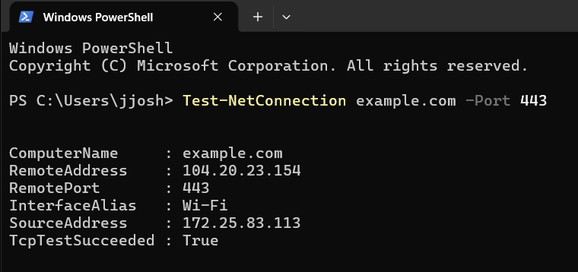
If expected packets are absent
If example.com:443 is blocked on campus or the network, use another authorized public HTTPS host and repeat; do not disable security protections.
Result to write after completion
The student assessed end-to-end reachability of a mobile Internet service from directly observed TCP connection setup.
Two analysis / viva questions
1. How does SYN-ACK differ from the first SYN?
2. Why is a successful TCP handshake not proof that an application response is correct?
What to submit: E05 capture file(s) + screenshot of relevant packets + completed observation table + a two- or three-sentence conclusion.

EXPERIMENT 06

Classify Shared-Network Traffic: Broadcast vs Unicast
Syllabus alignment: Access channels (conceptual comparison); cellular-network access concepts
Real-life scenario
In a crowded classroom, an instructor asks why some network requests are sent to everyone on the local link while others have a particular destination.
Lab question / problem statement
Produce and classify local broadcast traffic and directed unicast traffic. Relate the finding to shared-medium access, while explaining why it is NOT a cellular RACH capture.
Aim
To capture and analyze live network traffic in Wireshark in order to classify shared-network traffic: broadcast vs unicast.
Requirements
Wi-Fi connected laptop (hotspot or campus); Wireshark; Command Prompt.
Wireshark display filters
arp
eth.dst == ff:ff:ff:ff:ff:ff
ip && !(ip.dst == 255.255.255.255)

Step-by-step procedure
01. Connect to a permitted Wi-Fi/hotspot network and obtain the gateway IP from ipconfig.
02. Start Wireshark on the Wi-Fi adapter.
03. Generate an ARP request by reconnecting to the hotspot or, if authorized, clearing the ARP cache and pinging the gateway.
04. Run ping -n 4 1.1.1.1 to create ordinary directed IP communication.
05. Stop capture and filter arp. Identify packets sent to the local broadcast destination when present.
06. Apply eth.dst == ff:ff:ff:ff:ff:ff and record the visible broadcast packets.
07. Apply ip and select an external ICMP packet; note that its destination IP is a single host rather than the local broadcast destination.
08. Optional: try mdns || llmnr to see whether local multicast-name discovery happens naturally. Absence is normal.
09. Save E06_Broadcast_Unicast.pcapng and create a two-column table with examples of the two traffic types.
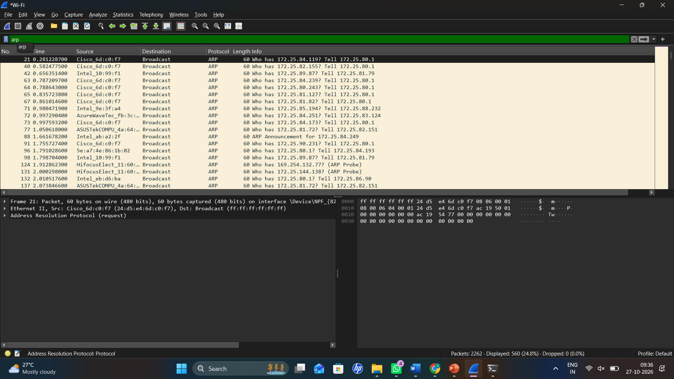
ARP Broadcast Traffic
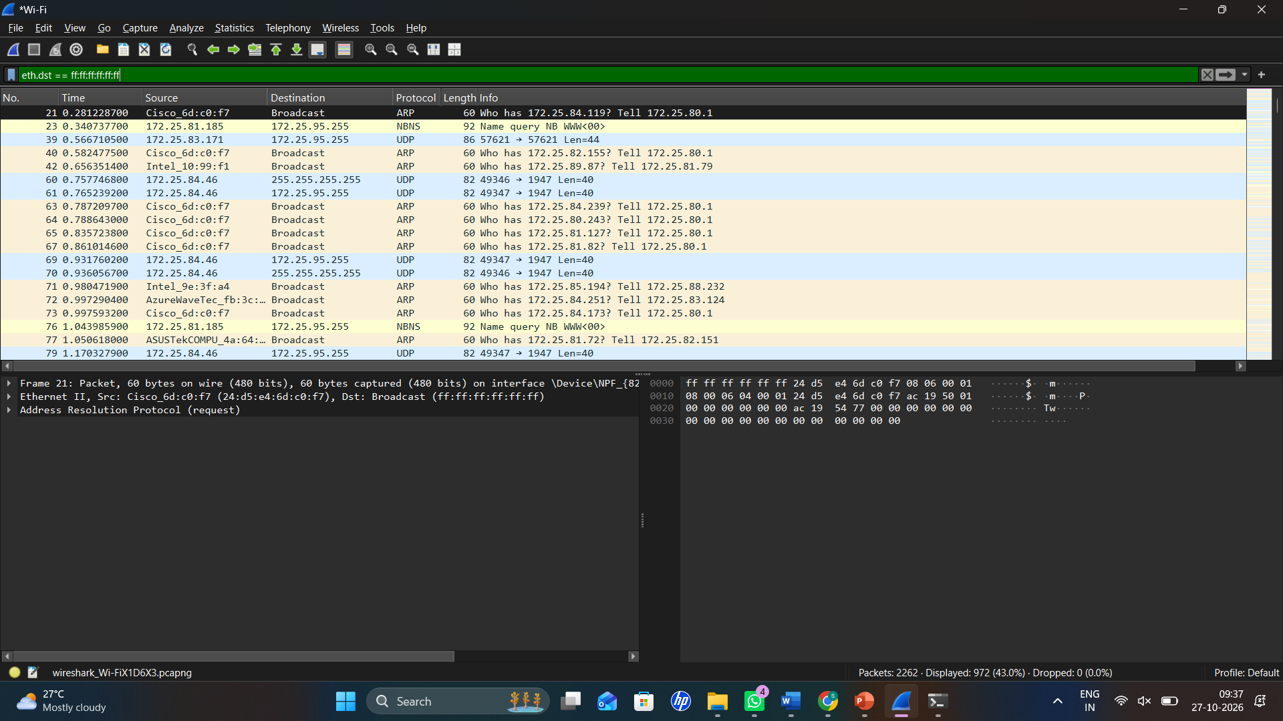
Ethernet Broadcast Destination Address
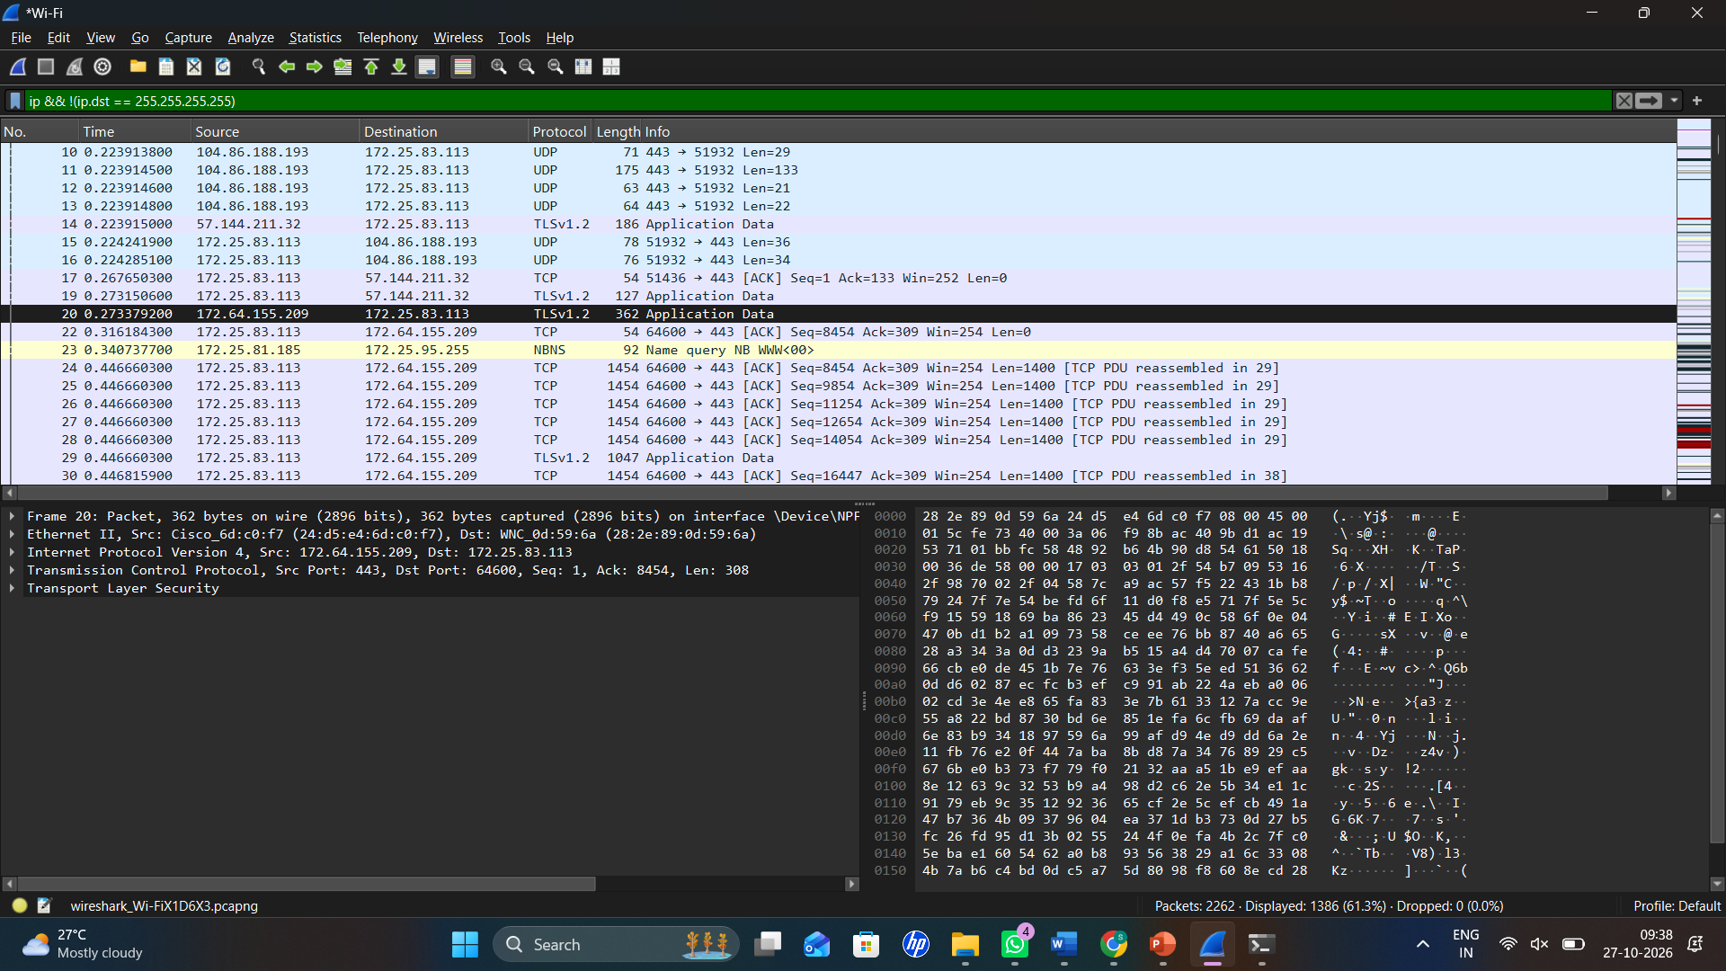
Unicast TCP Communication

Student observation sheet (fill with actual values)
Observation to record | Value from YOUR capture
Example broadcast protocol | _________ ARP___________________
Broadcast destination MAC | __________ ff:ff:ff:ff:ff:ff__________________
Example unicast protocol | ___________ TCP_________________
Unicast destination IP | ____________ 172.64.155.209________________
Multicast seen? (optional) | ___________ Not confirmed_________________

Expected output / how to interpret it
- ARP requests often use the all-ones Ethernet broadcast address.
- Internet-directed traffic generally uses unicast IP addressing, even when the local next-hop MAC is the gateway’s MAC.
- This experiment is an analogy to shared-access communication only. GSM/LTE random access channel procedures are NOT captured.
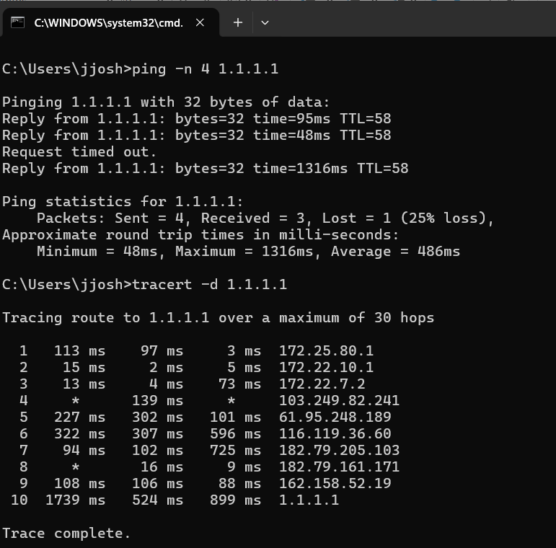
If expected packets are absent
If no ARP request appears, repeat after reconnecting or use another newly joined local network. Do not claim that multicast must be present.
Result to write after completion
The student distinguished local broadcast from directed unicast traffic and correctly described the limits of the Wi-Fi analogy to cellular access channels.
Two analysis / viva questions
1. Why can a packet have a remote destination IP but the gateway’s MAC address?
2. Why does observing ARP not prove which LTE/5G access channel was used?
What to submit: E06 capture file(s) + screenshot of relevant packets + completed observation table + a two- or three-sentence conclusion.

EXPERIMENT 07

Trace the Route from a Mobile Hotspot Toward the Internet
Syllabus alignment: Mobile network architecture; core networks; packet routing; cellular system operations
Real-life scenario
A user says that the hotspot shows 4G/5G connectivity but an Internet service remains unreachable. The faculty asks where the path stops responding.
Lab question / problem statement
Use a Windows traceroute and Wireshark to identify observable IP hops and ICMP Time Exceeded responses along the path.
Aim
To capture and analyze live network traffic in Wireshark in order to trace the route from a mobile hotspot toward the internet.
Requirements
Laptop on smartphone hotspot, Wireshark, Command Prompt. Normal cellular data is sufficient.
Wireshark display filters
icmp
icmp.type == 11
ip.addr == 1.1.1.1

Step-by-step procedure
01. Connect laptop to the mobile hotspot and obtain the gateway with ipconfig.
02. Start a Wireshark capture on the laptop Wi-Fi interface.
03. Open Command Prompt. Run tracert -d -h 10 1.1.1.1 (the -d option avoids reverse-DNS delay).
04. Let traceroute finish or stop after sufficient observed hops if it is slow.
05. Stop Wireshark capture and apply icmp. Locate outgoing ICMP Echo requests and possible ICMP Time Exceeded responses.
06. Inspect outgoing IP Time To Live values and the IP source addresses of any intermediate router responses.
07. Compare the Windows hop list with the IP addresses shown in Wireshark. Mark asterisks or nonresponding hops as unknown.
08. Sketch Laptop -> Hotspot -> Observable Internet/IP hops -> Destination. Draw the cellular provider core as an inferred, not directly decoded, part of the middle path.
09. Save E07_Mobile_Traceroute.pcapng and a screenshot showing ICMP replies if any.
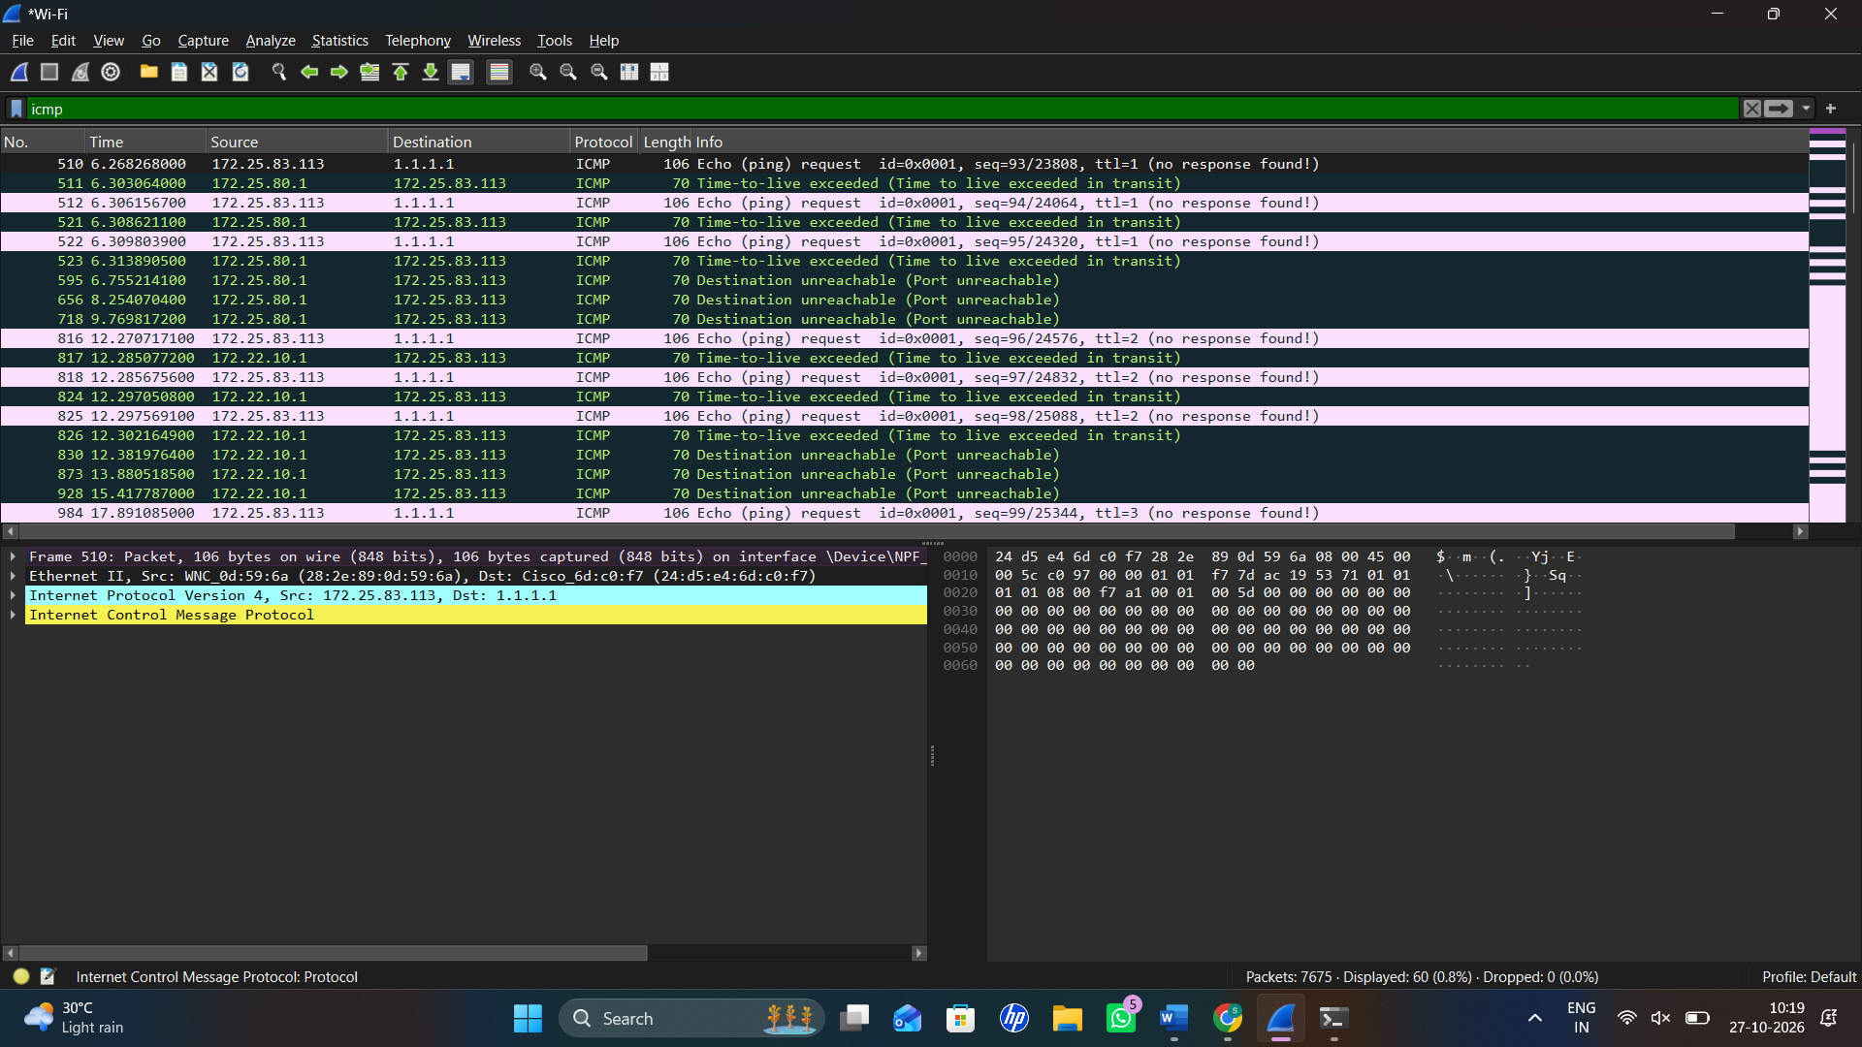

Student observation sheet (fill with actual values)
Observation to record | Value from YOUR capture
Laptop default gateway | _______ 172.25.80.1_____________________
Hop 1 seen in tracert | _____________ 172.25.80.1_______________
Number of replying intermediate hops | ____________ 4 (Hops 1, 2, 3 and 12 replied before the destination)________________
ICMP Time Exceeded visible? | __________ yes__________________
Any * * * nonresponding hops? | ______ Yes — Hops 4–11______________________

Expected output / how to interpret it
- Windows tracert sends probes with controlled TTL values; responding routers may return ICMP Time Exceeded.
- Some cellular networks use NAT, private addressing or suppress ICMP, so many hops may not reply.
- A sequence of IP hops cannot by itself identify a particular BSS, NSS, PLMN or 5G network function.
- 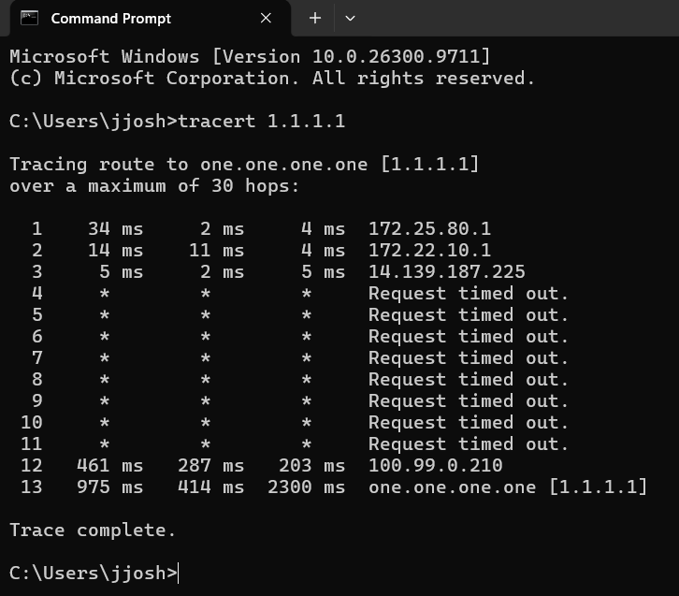

If expected packets are absent
If traceroute replies are largely suppressed, record the outgoing probes, TTL changes and unresponsive hops; optionally run ping -i 1 -n 3 1.1.1.1 to request a low-TTL probe.
Result to write after completion
The student investigated end-to-end routing through a mobile Internet connection and learned which parts of the operator network are visible only as IP behavior.
Two analysis / viva questions
1. What does the IPv4 TTL field do?
2. Does a timeout at a traceroute hop prove the network is broken?
What to submit: E07 capture file(s) + screenshot of relevant packets + completed observation table + a two- or three-sentence conclusion.

EXPERIMENT 08

Observe Service Interruption During a Network Switch
Syllabus alignment: Mobility; handoff; service continuity; performance criteria
Real-life scenario
During an online class, a laptop changes from campus Wi-Fi to a student smartphone hotspot and the video call pauses momentarily.
Lab question / problem statement
Measure observable changes in IP configuration and connectivity while moving from one access network to another. Explain why this is an IP-network-switch analogue, not cellular handoff signaling.
Aim
To capture and analyze live network traffic in Wireshark in order to observe service interruption during a network switch.
Requirements
Two authorized networks: campus Wi-Fi + smartphone hotspot (or two hotspots); Windows laptop; Wireshark; Command Prompt.
Wireshark display filters
icmp || bootp || arp
icmp

Step-by-step procedure
01. Connect to Network A (campus Wi-Fi). Run ipconfig and write down its IPv4 and default gateway.
02. Open Wireshark and start capturing on the Wi-Fi interface. Save later as the experiment file.
03. Open Command Prompt and run ping -t 1.1.1.1; leave it running for roughly 10 successful requests.
04. Using Windows Wi-Fi settings, disconnect from Network A and connect to Network B (the phone hotspot). Leave ping running.
05. After Network B connects, let another 10-15 ping requests run, then stop ping with Ctrl+C.
06. Run ipconfig again to record the new IPv4 and default gateway.
07. Stop capture. Filter icmp || bootp || arp and locate the last replies from Network A and the first replies from Network B, if the adapter continued capturing.
08. If the capture stopped when Wi-Fi reset, make a second capture on Network B and compare the two pcapng files, using the ping log to describe the interruption.
09. Record how many ping requests timed out and whether IP/gateway values changed; save E08_Network_Switch.pcapng (and E08_PartB.pcapng if needed).
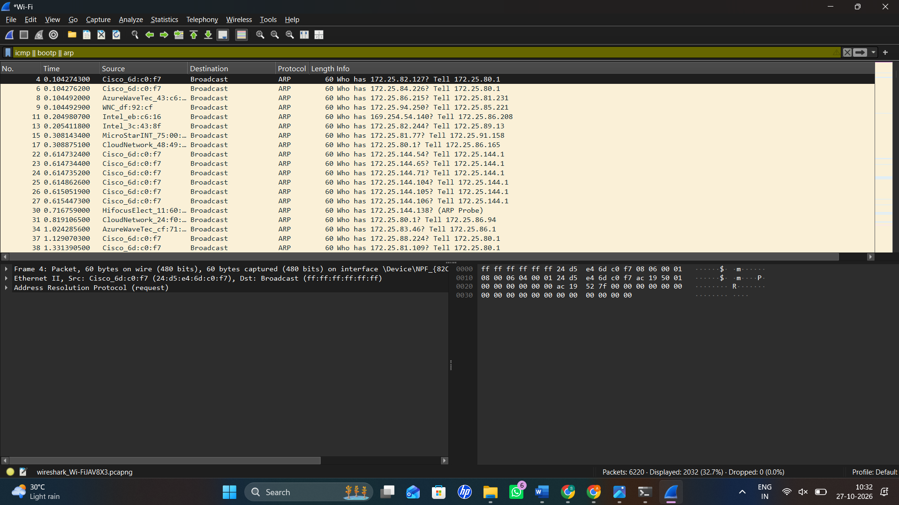

Student observation sheet (fill with actual values)
Observation to record | Value from YOUR capture
Network A IPv4/gateway | __________________ 172.25.83.113_/ 172.25.80.1_________
Network B IPv4/gateway | __________________ 192.168.43.120/ 192.168.43.1________
Ping requests lost during switch | ___________ Approximately 2–3 requests___________
Any reconnection/DHCP packets seen? | _______________________ ARP and DHCP packets may appear during reconnection_____
Was capture continuous? | ______________________  No, if the Wi-Fi adapter reset during switching  ______

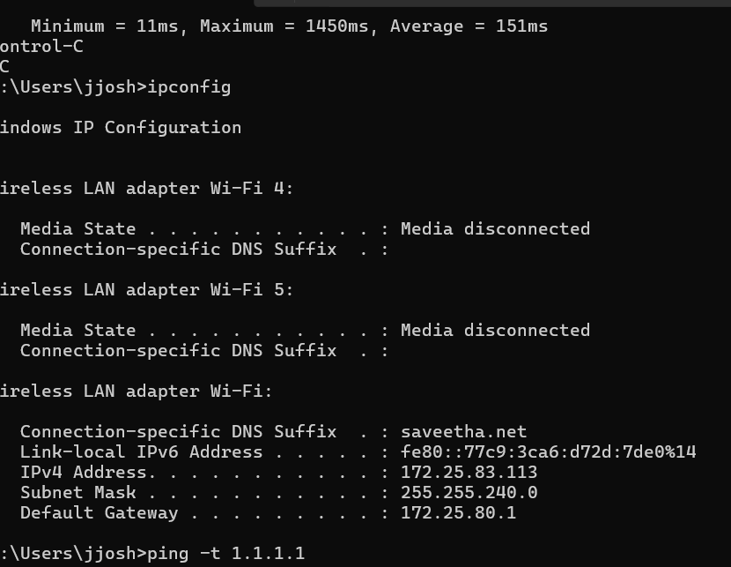

Expected output / how to interpret it
- An interruption and/or IP change is common when switching between distinct access networks; duration varies.
- The continuing ping tests reachability, while Wireshark shows traffic on the laptop-facing network.
- This is NOT a native GSM/LTE/5G cell handover capture; cellular handover control messages are not shown.
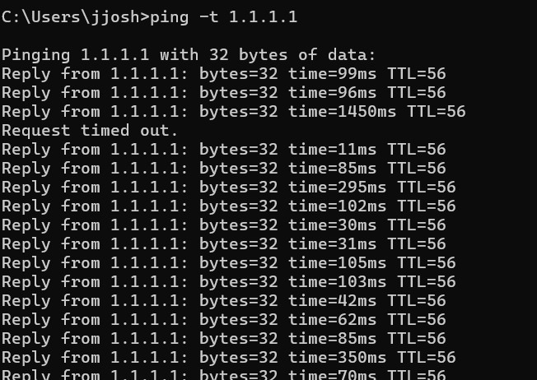

If expected packets are absent
If there is no packet loss during the switch, report the zero-loss observation. If the Wi-Fi adapter resets and ends capture, save two sequential captures instead.
Result to write after completion
The student measured an observable access-network transition and related the service gap to mobility concepts without claiming to capture cellular handover messages.
Two analysis / viva questions
1. What would preserve an ongoing application session better during a real handoff?
2. Why can the same Wi-Fi adapter keep one IP on one network but get another IP on the next?
What to submit: E08 capture file(s) + screenshot of relevant packets + completed observation table + a two- or three-sentence conclusion.

EXPERIMENT 09

Assess Mobile Hotspot Performance at Two Indoor Locations
Syllabus alignment: Performance criteria; coverage; frequency/interference as possible causes
Real-life scenario
Two students report different video-lecture quality while connected to the same phone hotspot: one sits next to the phone and the other farther away behind a wall.
Lab question / problem statement
Using repeatable ICMP tests captured in Wireshark, compare round-trip time and packet loss at two safe classroom positions. Can the trace alone prove radio interference?
Aim
To capture and analyze live network traffic in Wireshark in order to assess mobile hotspot performance at two indoor locations.
Requirements
Laptop, phone hotspot with sufficient mobile data, Wireshark, Command Prompt; two safe indoor test positions.
Wireshark display filters
icmp
icmp.type == 8 || icmp.type == 0

Step-by-step procedure
01. Position A: place the laptop near the hotspot (e.g., the same desk). Keep the smartphone location fixed if possible.
02. Connect to the hotspot and start Wireshark capture.
03. Run ping -n 25 1.1.1.1 in Command Prompt. Save the minimum, maximum, average RTT and packet-loss statistics.
04. Stop capture and save E09_Position_A.pcapng.
05. Position B: move the laptop to a safe, more distant location in the same room or just beyond an interior wall while keeping the hotspot in its original position.
06. Restart Wireshark capture on the same Wi-Fi adapter; run ping -n 25 1.1.1.1 again.
07. Stop capture and save E09_Position_B.pcapng.
08. For each file, filter icmp, count observed requests and replies, and compare timing using packet timestamps. Statistics > I/O Graphs can help visualize packet activity.
09. Fill in the two-location comparison table and state plausible causes carefully: Wi-Fi strength, cellular link variation, Internet congestion and ICMP prioritization can all affect results.
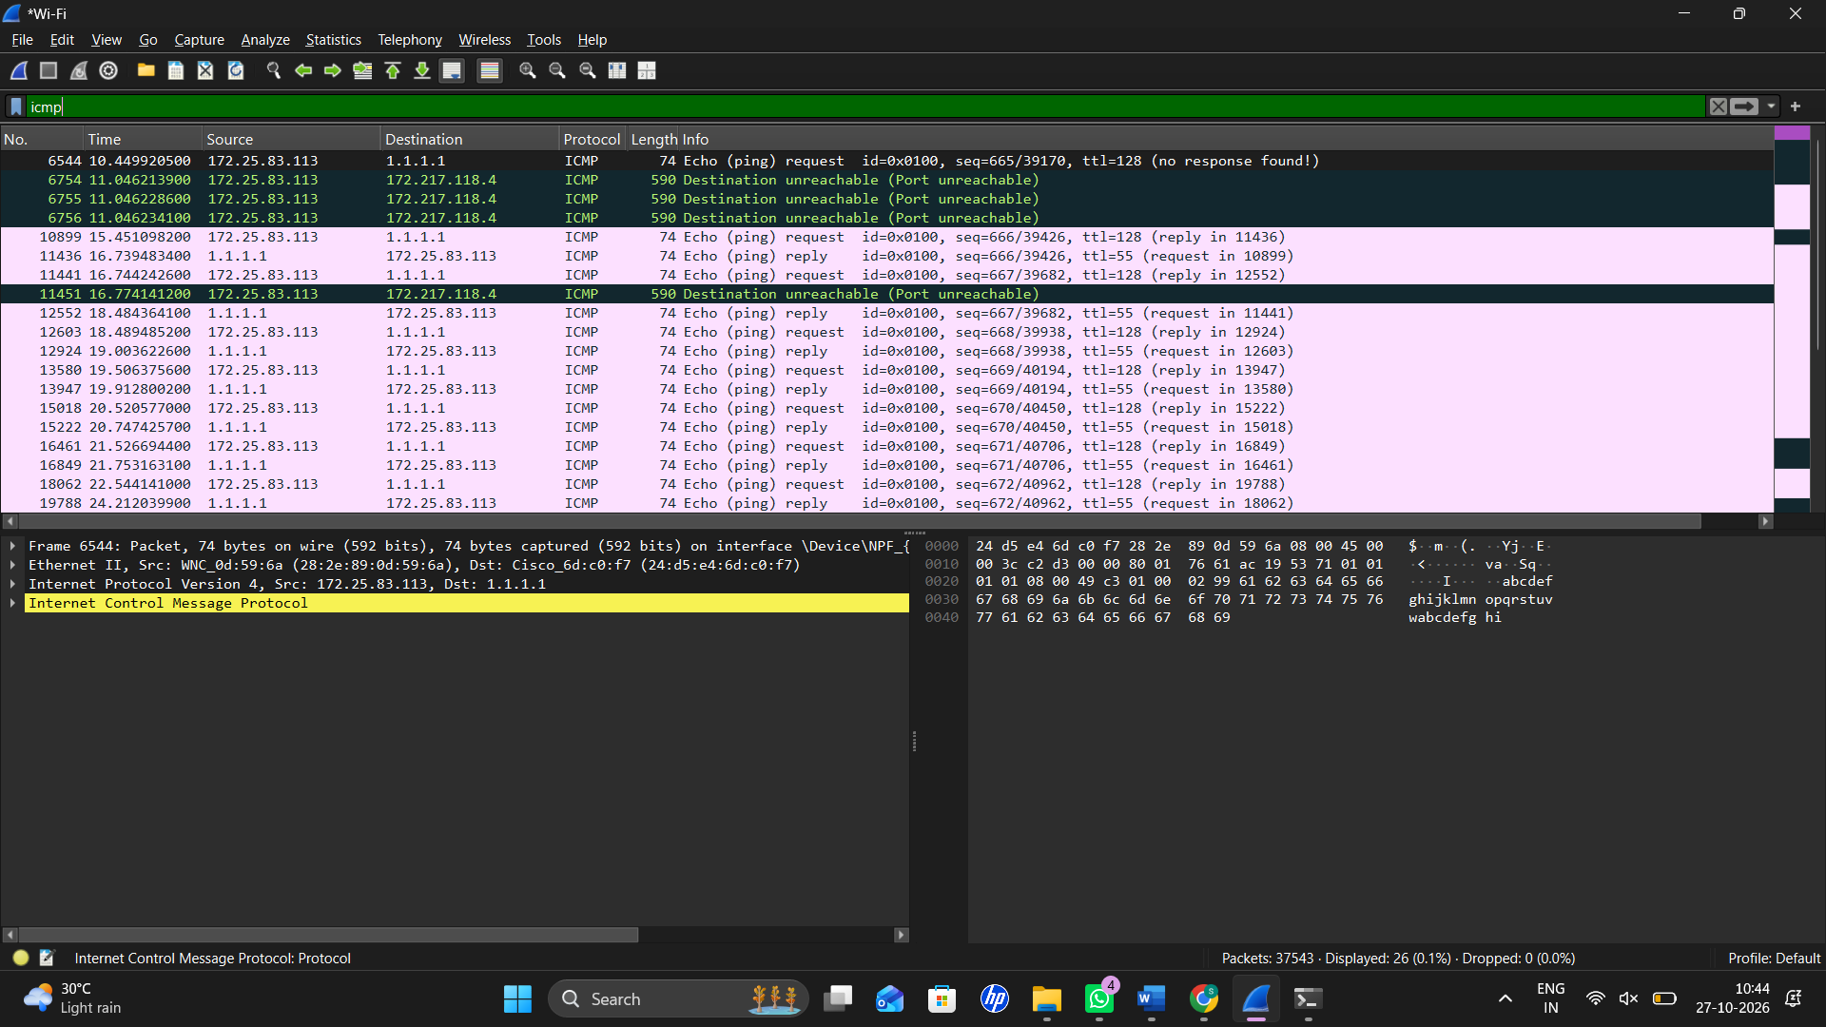

Student observation sheet (fill with actual values)
Observation to record | Value from YOUR capture
Position A: min / avg / max RTT (ms) | _______ 226 ms / 854 ms / 1740 ms_______________
Position A: sent / received / lost | ______________10 / 9 / 1  __________
Position B: min / avg / max RTT (ms) | _______ Not yet tested_____________________
Position B: sent / received / lost | __________ Not yet tested__________________
Interpretation and possible confounders | ______________________  Position A showed high latency and 10% packet loss. Possible causes include mobile network congestion, Wi-Fi signal strength, or internet connection variation.  ______

Expected output / how to interpret it
- The two locations may show different RTT or loss, but equal results are also valid.
- Wireshark measures IP/ICMP behavior, not RF frequency reuse or signal-to-interference ratios in normal capture mode.
- A change in latency alone cannot establish a particular interference source.
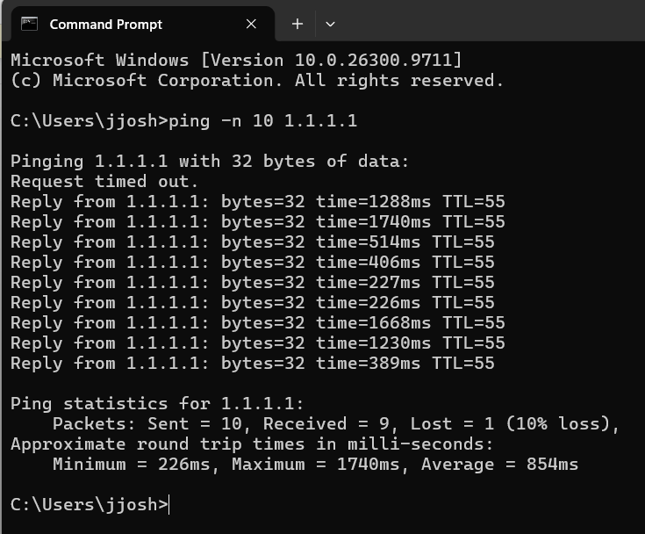
If expected packets are absent
If ICMP is blocked, choose a permitted responsive destination, or report the restriction and perform the test against the reachable local gateway (clearly state it becomes a local-link test).
Result to write after completion
The student compared observed hotspot performance using a controlled live packet test and correctly separated network performance evidence from unmeasured radio interference.
Two analysis / viva questions
1. Why might packet loss remain zero even when wireless signal bars decrease?
2. Which additional instrument would be required to measure cellular interference or frequency reuse directly?
What to submit: E09 capture file(s) + screenshot of relevant packets + completed observation table + a two- or three-sentence conclusion.

EXPERIMENT 10

Compare Campus Wi-Fi and Cellular-Data Hotspot Paths
Syllabus alignment: Core networks; PLMN; roaming; mobile network operations and service differences
Real-life scenario
A student notices that a website works on campus Wi-Fi but not when using mobile data. The network administrator asks for an evidence-based comparison rather than guessing that the phone’s PLMN is faulty.
Lab question / problem statement
Capture the same tests on two access networks and compare their gateway, DNS, IP route and reachable TCP service. Describe what Wireshark can and cannot establish about PLMN or roaming.
Aim
To capture and analyze live network traffic in Wireshark in order to compare campus wi-fi and cellular-data hotspot paths.
Requirements
Laptop, authorized campus Wi-Fi, smartphone hotspot, Wireshark, Command Prompt and Windows PowerShell.
Wireshark display filters
dns || icmp || tcp
tcp.port == 443 || dns || icmp

Step-by-step procedure
01. Network A (campus Wi-Fi): connect and open Wireshark capture on the Wi-Fi interface.
02. Run ipconfig; nslookup example.com; ping -n 4 1.1.1.1; and PowerShell command Test-NetConnection example.com -Port 443.
03. Stop and save E10_CampusWiFi.pcapng. Record assigned IPv4, gateway, DNS response and TCP reachability.
04. Network B (smartphone hotspot): switch to your phone hotspot and begin a NEW Wireshark capture on the Wi-Fi interface.
05. Run the same four commands as in Network A, with the same host and same amount of traffic.
06. Stop and save E10_MobileHotspot.pcapng.
07. Open each capture separately and apply dns || icmp || tcp. Compare request/response presence, endpoint IPs and protocol behavior.
08. Explain how the smartphone has a cellular-operator path beyond the laptop’s Wi-Fi gateway, while the campus network uses an institution-managed upstream path.
09. Fill in the comparison table. State explicitly that SIM roaming, MCC/MNC, registration, and the operator’s PLMN signaling are not determined from these Wireshark captures.
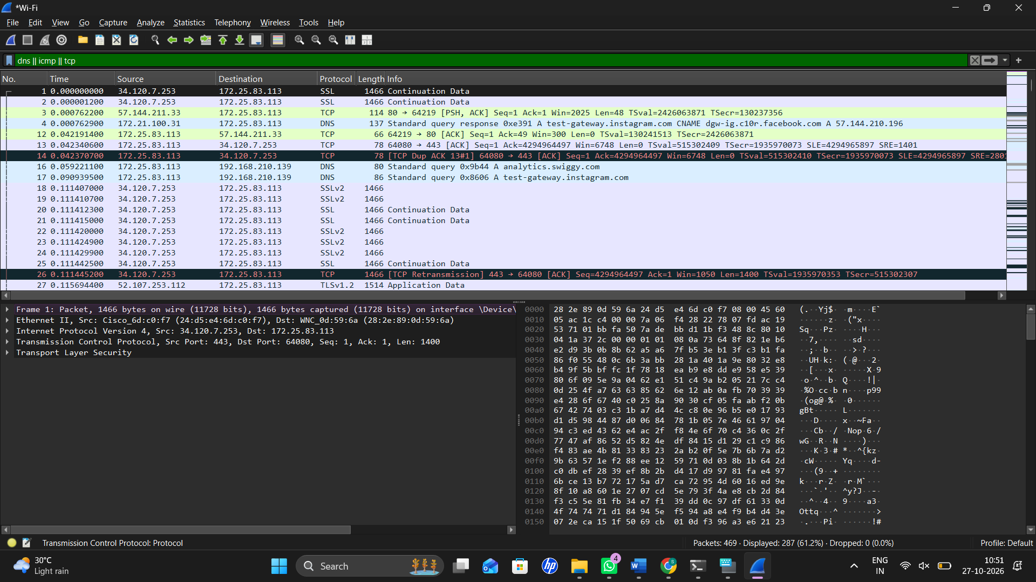

Student observation sheet (fill with actual values)
Observation to record | Value from YOUR capture
Campus network: IPv4 / gateway | ________172.25.83.113/172.25.80.1____________________
Hotspot network: IPv4 / gateway | _______Not available — mobile data/hotspot test not performed_____________________
Campus DNS and TCP test result | ________DNS lookup timed out. TCP port 443 test succeeded (TcpTestSucceeded: True)____________________
Hotspot DNS and TCP test result | _________Not tested — mobile data unavailable ____________
PLMN/roaming directly observed? (No) | _______No. PLMN and roaming status were not directly observed in the laptop's Wireshark capture._____________________
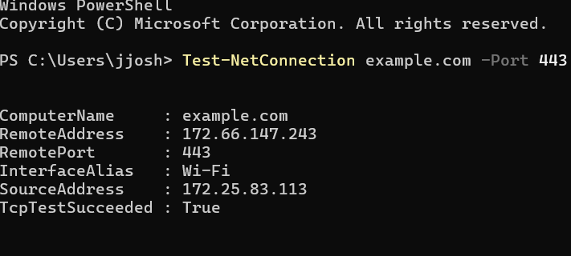

Expected output / how to interpret it
- The local IP address and first-hop gateway generally differ between campus and hotspot networks.
- Both networks can serve the same application using different network paths, DNS resolvers or IP configurations.
- The comparison does not prove whether a mobile SIM is roaming or which PLMN/network code is selected.
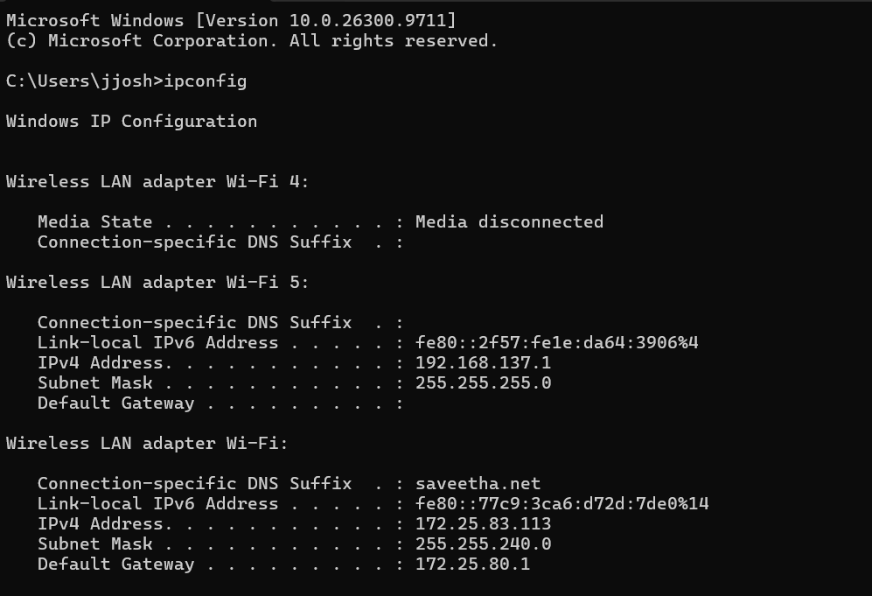
If expected packets are absent
If campus Wi-Fi blocks ICMP or port 443, record the policy-dependent failure as an actual result; do not bypass campus security. Tests remain valid as a documented comparison.
Result to write after completion
The student compared live service operation on a campus access network and a cellular-data-backed hotspot, identifying observed protocol differences and the limits of PLMN inference.
Two analysis / viva questions
1. What specific evidence is needed to identify a PLMN or roaming registration?
2. Why can different access networks return different DNS answers?
What to submit: E10 capture file(s) + screenshot of relevant packets + completed observation table + a two- or three-sentence conclusion.

Faculty guide: coverage and practical boundaries
These are real-time Wireshark exercises derived from Unit I, not substitutes for a cellular air-interface analyzer. The table helps faculty prevent incorrect inferences during assessment.
Unit I syllabus phrase | What students can demonstrate with Wireshark | What is NOT directly measured
Fundamentals / protocol stacks | IP, TCP, UDP, DNS, ARP, DHCP and ICMP traffic | Internal LTE/NR stack
Mobile station / BSS / NSS | Laptop and gateway path; conceptual architecture diagram | Base-station or switching signaling
Access channels | Shared-network broadcast vs unicast analogy | Cellular random access channel
Core networks / PLMN | Visible IP routes and first-hop differences | PLMN ID, MCC/MNC, SIM registration
Mobility / handoff / roaming | Network switching and service interruption analogy | Native cell handover/roaming negotiation
Performance / interference | RTT, loss, responses and timing | Radio frequency or signal-to-interference ratio

Suggested assessment scheme (10 marks per experiment)
Component | Marks
Setup and successful capture | 2
Correct live test and filter | 3
Observation table based on evidence | 2
Explanation and limits of inference | 2
Saved capture and screenshot | 1

